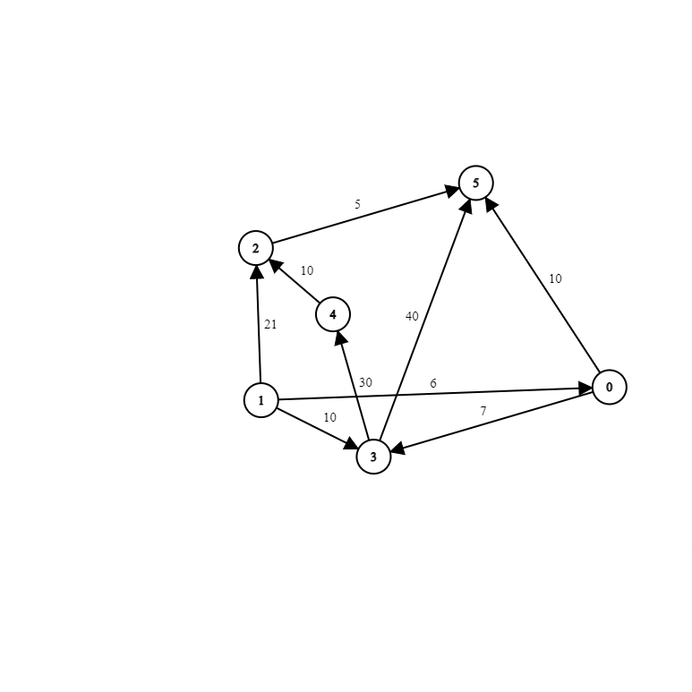

Dictionary_out: { 0 : [ 3 ,5 ]

1 : [ 0, 2, 3 ]

2 : [ 5 ]

3 : [ 4, 5 ]

4 : [ 2 ]

5 : [ ] }

Dictionary_in { 0 : [ 1 ]

1 : [ ]

2 : [ 1, 4 ]

3: [ 0, 1 ]

4 : [ 3 ]

5: [ 0, 2 , 3 ]

Input file:

6 9

0 5 10

0 3 7

1 0 6

1 3 10

1 2 21

3 4 30

3 5 40

4 2 10

2 5 5

Topological sorts:

410325 412035 142035 103425 410235 103425 013425 142035

Highest cost paths:

0 🡪 3 (7)

0 🡪 3 🡪 4 🡪 2 🡪 5 (52)

1 🡪 0 (6)

1 🡪 0 🡪 3 🡪 4 🡪 2 (53)

1 🡪 0 🡪 3 (13)

2 🡪 5 (5)

3 🡪 4 (30)

3 🡪 4 🡪 2 🡪 5 (45)

4 🡪 2 (10)